**WEEK 1:**

**EXERCISE 1: Implementing the Singleton Pattern**

**Solution:**

**Logger.java:**

public class Logger {

    private static Logger instance;

    private Logger() {

        System.out.println("Logger instance created");

    }

    public static Logger getInstance() {

        if (instance == null) {

            instance = new Logger();

        }

        return instance;

    }

    public void log(String message) {

        System.out.println("LOG: " + message);

    }

}

Loggertest.java:

public class Loggertest {

    public static void main(String[] args) {

        Logger logger1 = Logger.getInstance();

        Logger logger2 = Logger.getInstance();

        logger1.log("First message");

        logger2.log("Second message");

        if (logger1 == logger2) {

            System.out.println("Both logger instances are the same (Singleton works)");

        } else {

            System.out.println("Logger instances are different (Singleton failed)");

        }

    }

}

OUTPUT:

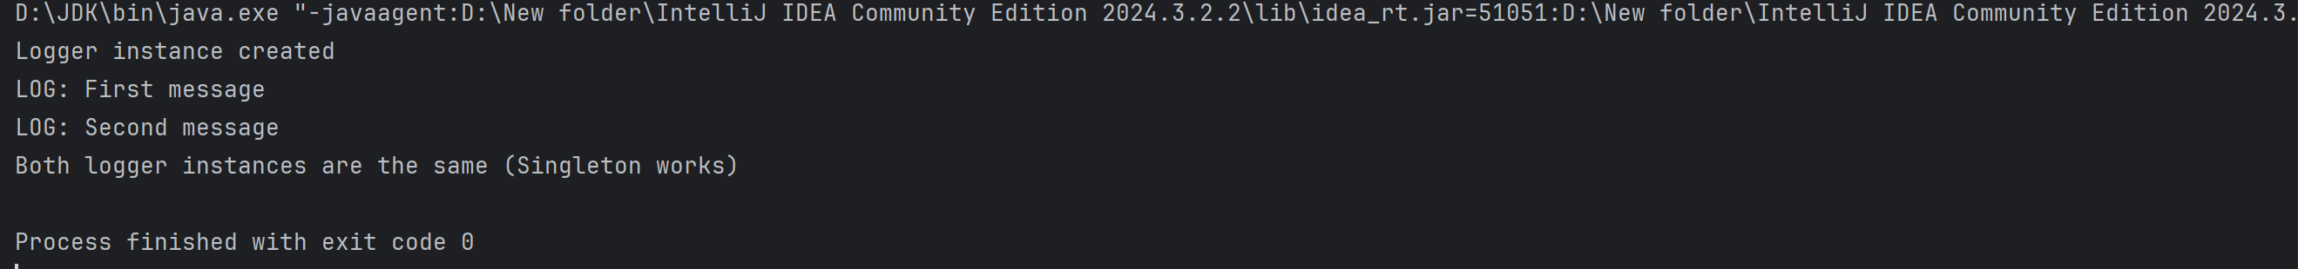

**Exercise 2: Implementing the Factory Method Pattern**

**Solution:**

public class FactoryTest {

    public static void main(String[] args) {

        DocumentFactory wordFactory = new WordDocumentFactory();

        Document wordDoc = wordFactory.createDocument();

        wordDoc.open();

        DocumentFactory pdfFactory = new PdfDocumentFactory();

        Document pdfDoc = pdfFactory.createDocument();

        pdfDoc.open();

        DocumentFactory excelFactory = new ExcelDocumentFactory();

        Document excelDoc = excelFactory.createDocument();

        excelDoc.open();

    }

}

// Interface

interface Document {

    void open();

}

// Concrete Documents

class WordDocument implements Document {

    public void open() {

        System.out.println("Opening a Word document.");

    }

}

class PdfDocument implements Document {

    public void open() {

        System.out.println("Opening a PDF document.");

    }

}

class ExcelDocument implements Document {

    public void open() {

        System.out.println("Opening an Excel document.");

    }

}

// Abstract Factory

abstract class DocumentFactory {

    public abstract Document createDocument();

}

// Concrete Factories

class WordDocumentFactory extends DocumentFactory {

    public Document createDocument() {

        return new WordDocument();

    }

}

class PdfDocumentFactory extends DocumentFactory {

    public Document createDocument() {

        return new PdfDocument();

    }

}

class ExcelDocumentFactory extends DocumentFactory {

    public Document createDocument() {

        return new ExcelDocument();

    }

}

**Output:**

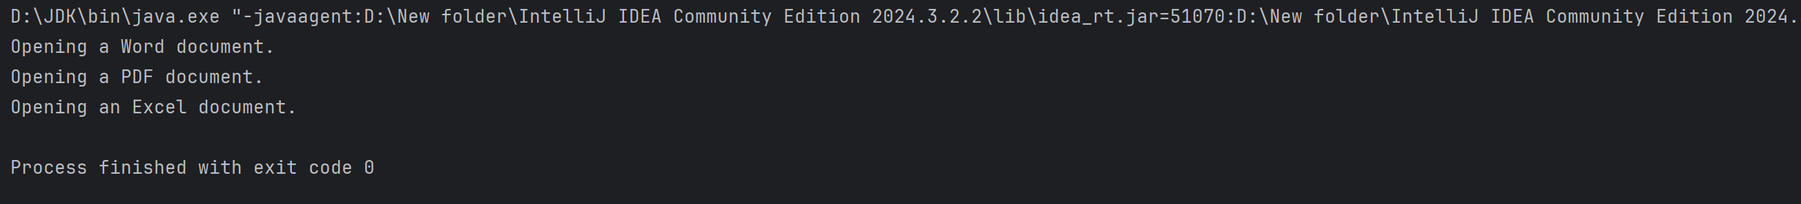

**Exercise 3: E-commerce Platform Search Function**

**Solution:**

import java.util.Arrays;

import java.util.Comparator;

class Product {

    int productId;

    String productName;

    String category;

    public Product(int id, String name, String category) {

        this.productId = id;

        this.productName = name;

        this.category = category;

    }

    public String toString() {

        return "ProductID: " + productId + ", Name: " + productName + ", Category: " + category;

    }

}

class SearchUtils {

    public static Product linearSearch(Product[] products, String targetName) {

        for (Product p : products) {

            if (p.productName.equalsIgnoreCase(targetName)) {

                return p;

            }

        }

        return null;

    }

    public static Product binarySearch(Product[] products, String targetName) {

        int low = 0, high = products.length - 1;

        while (low <= high) {

            int mid = (low + high) / 2;

            int cmp = products[mid].productName.compareToIgnoreCase(targetName);

            if (cmp == 0) return products[mid];

            else if (cmp < 0) low = mid + 1;

            else high = mid - 1;

        }

        return null;

    }

    public static void sortByName(Product[] products) {

        Arrays.sort(products, Comparator.comparing(p -> p.productName.toLowerCase()));

    }

}

public class SearchTest {

    public static void main(String[] args) {

        Product[] products = {

            new Product(101, "Laptop", "Electronics"),

            new Product(102, "Shoes", "Fashion"),

            new Product(103, "Watch", "Accessories"),

            new Product(104, "Phone", "Electronics"),

            new Product(105, "Tablet", "Electronics")

        };

        System.out.println(" Linear Search:");

        Product linearResult = SearchUtils.linearSearch(products, "Watch");

        System.out.println(linearResult != null ? linearResult : "Product not found");

        // Must sort before binary search

        SearchUtils.sortByName(products);

        System.out.println("\n Binary Search:");

        Product binaryResult = SearchUtils.binarySearch(products, "Watch");

        System.out.println(binaryResult != null ? binaryResult : "Product not found");

    }

}

**Output:**

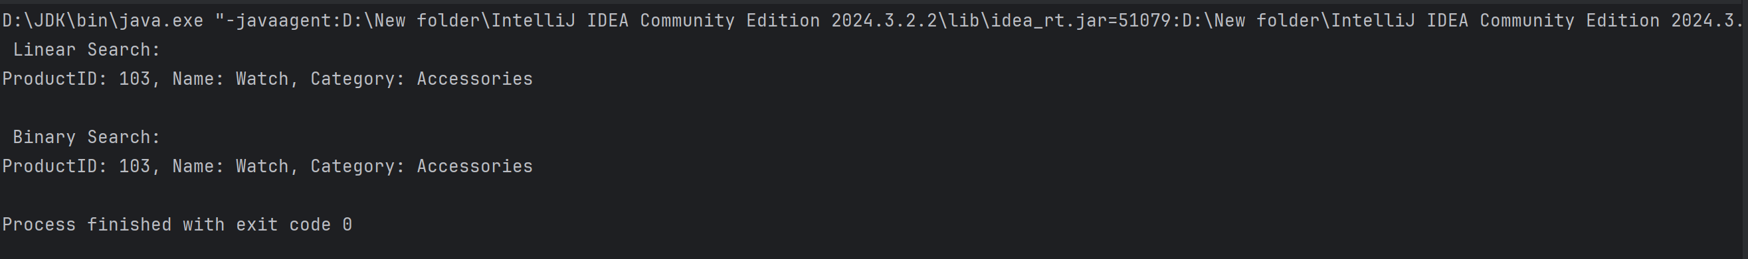

**Exercise 4: Financial Forecasting**

**Solution:**

public class FinancialForecastMemo {

static double[] memo;

public static double forecast(double initial, double rate, int year) {

if (year == 0) return initial;

if (memo[year] != 0) return memo[year];

memo[year] = forecast(initial, rate, year - 1) * (1 + rate);

return memo[year];

}

public static void main(String[] args) {

double initialValue = 1000.0;

double growthRate = 0.1; // 10%

int forecastYear = 10;

memo = new double[forecastYear + 1];

double result = forecast(initialValue, growthRate, forecastYear);

System.out.printf(" Forecasted value after %d years: ₹%.2f\n", forecastYear, result);

}}

**Output:**

